**BASIC FIREWALL CONFIGURATION (CLOSING A PORT TO BLOCK TRAFFIC)**

**Objective:** Configure Windows Firewall to close a port (ex: TCP/5555) and test it.

Earlier we followed a few steps and successfully opened TCP port 5555 to allow traffic on Windows 11 using Windows Defender. Now the task is to close the same port.

To check If a specific port is open/close on Windows, Type the following command in the command prompt:

“Test-NetConnection -Port 5555 -ComputerName localhost”

This command gives the following result,

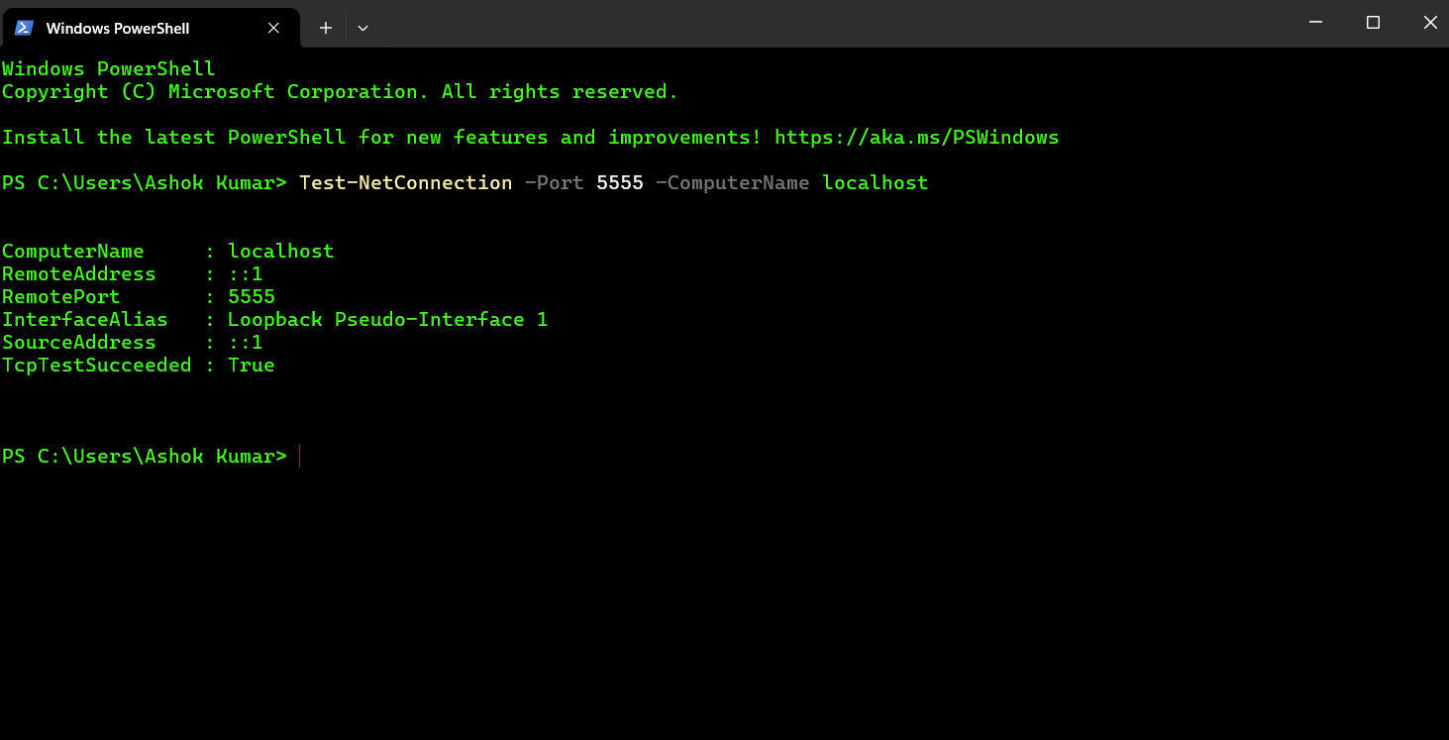

The image above shows that the port 5555 is open.

“TcpTestSucceeded : True”

After checking this we can now close this port to block traffic through it by following the steps below.

**Step 1:** Open Windows Defender Firewall with Advanced Security and on the top we can see that the port we open earlier appears with the same name “Port 5555_test”

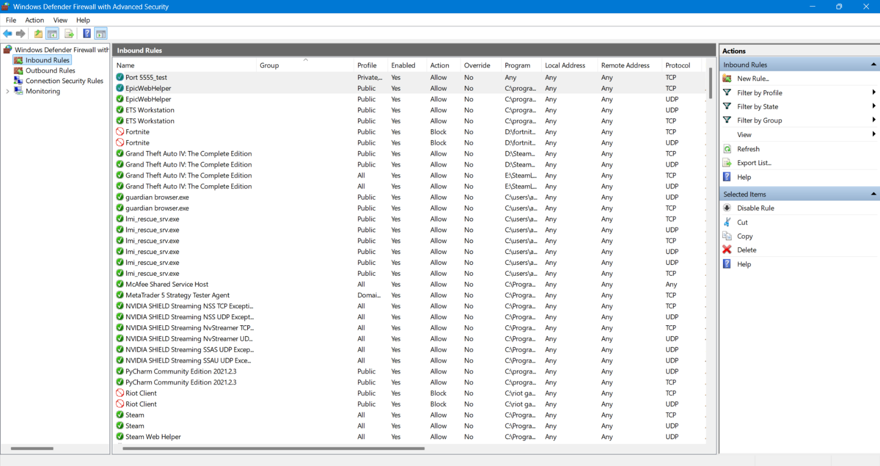

**Step 2:** Select the port by clicking on it and on the right hand side under the “Selected Items” we can see the options “Disable Rule” and “Delete”.

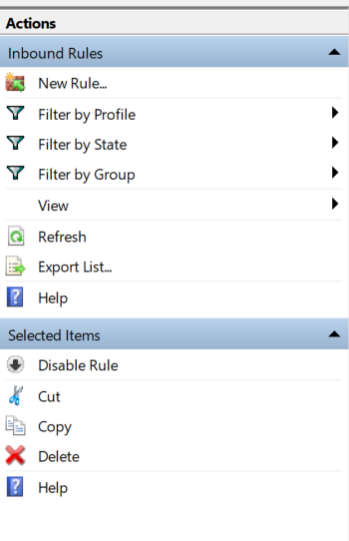

**Step 3:** We are going to delete it so click on the option delete and before doing that make sure you select the correct port.

After clicking on “Delete” a windows pops up as shown below,

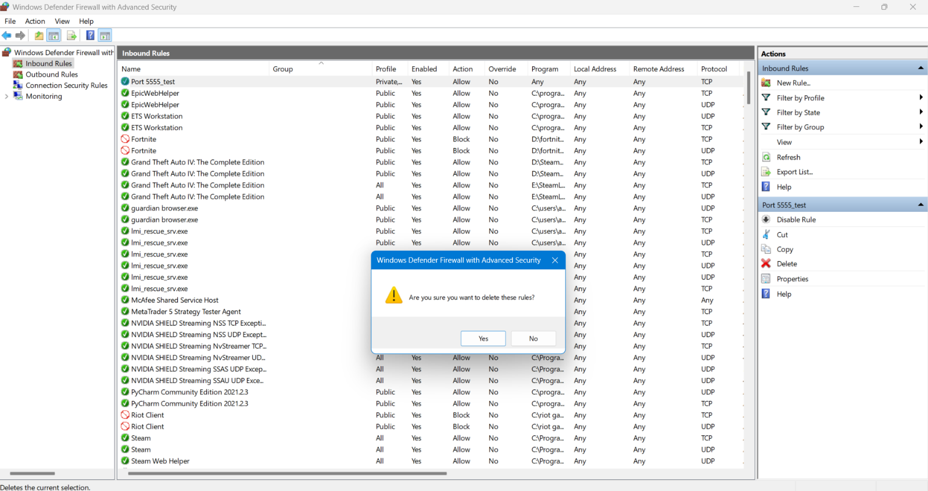

**Step 4:** We see an alert window pop up saying “Are you sure you want to delete these rules?”

Click on “Yes” and the rule is deleted. We can check this by observing the top of the list.

The name “Port 5555_test” no longer appears.

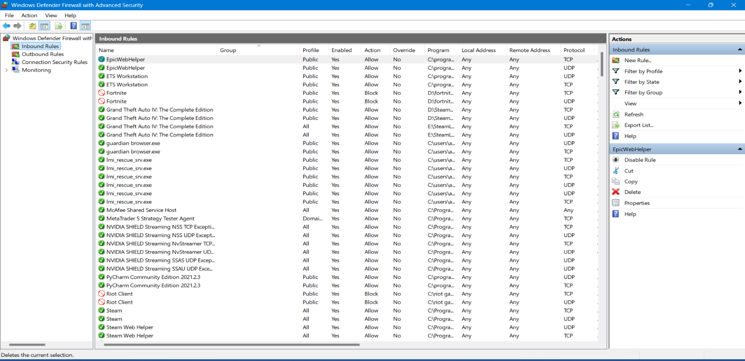

**Step 5:** All the steps are done to block the TCP/5555 port on your system using the Windows Defender in just a few steps. Now we just need to check if our operation was succesfull.

To do this we need to run the same command we ran in the beginning to check if that port is running or closed.

The image below shows how it works

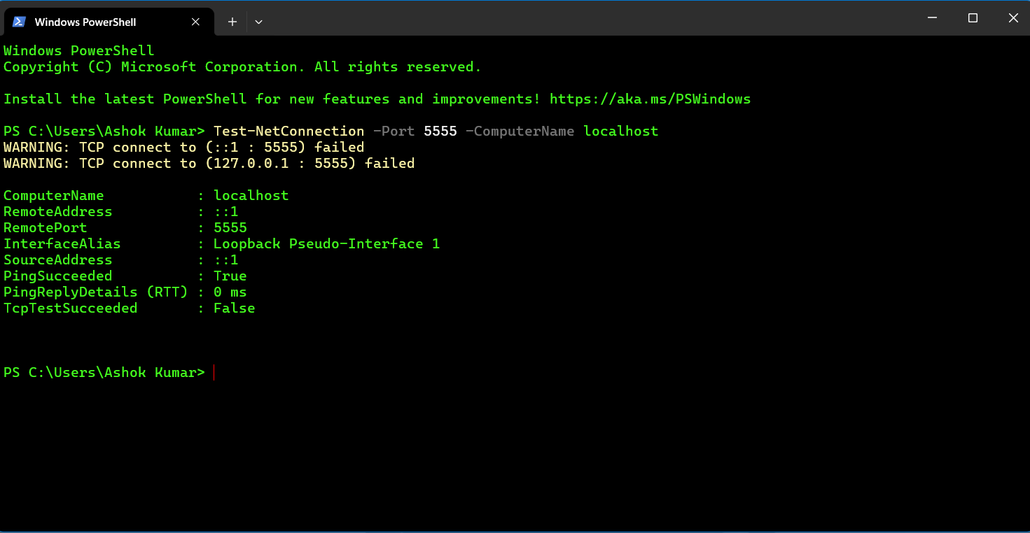

Result: Here we can see that the TCP/5555 port is now closed. This verifies that our Windows Defender configuration to block TCP port 5555 is successful.